MOSCONI CUP 2008 Packages

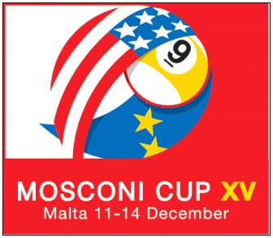

There are only a handful of sporting events that can truly be described as an unforgettable travel experience, and the Mosconi Cup is certainly at the top of that short list. So instead of watching the Mosconi Cup at home, maybe it’s time for you to experience it in person with Fraser Eagle Allevents travel package complete with Mosconi Cup match tickets and hotel accommodation. Fraser Eagle Allevents has a variety of Mosconi Cup travel packages available for you to pick from.

The Mosconi Cup is an annual nine-ball pool tournament contested between teams representing Europe and USA since 1994. Each team will have 5 players. The trophy is named after the American player William Mosconi and it has been referred to as the “Ryder Cup of Pool”. This is an event which is shown live in the UK. Sky Sports shows this event every year with over 20 hours of coverage across Sky sports 1 & 2 & 3.

This is good news for Malta in that, the main organisers of the Mosconi Cup Matchroom have entrusted this event to be held in Malta. It is probably due to the success and reputation Malta has obtained from the annual Snooker Malta Cup which has put Malta on the Snooker Calendar for the last 12 years. Fraser EAGLE Allevents are the ONLY accredited official travel agents to the Mosconi Cup.

No VISA restrictions for US passport holders.

Our Fraser Eagle Allevents travel packages will be available to purchase
on-line on: www.alleventsmalta.com

For more information about Malta please click on the following links:
About Malta Photo Gallery Why Malta

5* Hilton Hotel
Probably the best 5* hotel on the island. Located in the busy St Julians area, the hotel forms part of the Portomaso complex which incorporates luxury apartments, yacht marina, business tower, and shopping mall. 4 theme restaurants, pools, private beach, sauna, tennis, and a fully equipped congress center. This is the venue were the tournament will be taking place.
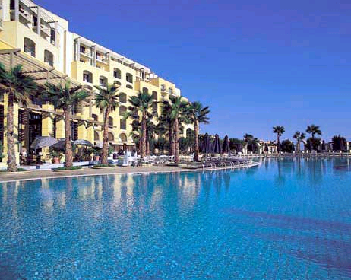

Monday 08th -Monday 15th December

8 night Package Single:€1031/£773/1191(USD)

8 night Package Twin :€1342/£1006/1550(USD)

Thursday 11th -Monday 15th December

4 night Package Single:€ 627/£471/966(USD)

4 night Package Twin :€832/£624/1281(USD)

- Admission to All the Matches.
- Thursday Opening Ceremony.
- Private Airport Transfers.
- Buffet Breakfast.
- Official souvenir program signed by one of the players.
- Staff on site to assist.
- This package is to be sold in Euros.
- The above conversions are subject to exchange fluctuations.

Book your package early to avoid disappointment.

**Special Offers on Flights @ 216 euros**

ON LINE BOOKINGS: www.alleventsmalta.com

For any bookings/enquiries please contact us on: office@alleventsmalta.com
5* Intercontinental Hotel

InterContinental Malta gives you the best of all worlds: a luxury waterfront resort complete with private beach and water sports; a central cosmopolitan location close to shopping, entertainment and historic sites; and an array of services appreciated by leisure and business travellers alike. This hotel is approxemetly 20 minutes away from the airport by taxi.

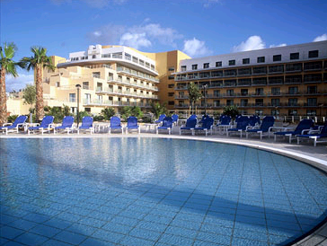

Monday 08th -Monday 15th December

8 night Package Single:€895/£671/1033(USD)

8 night Package Twin :€1205/£904/1392(USD)

Thursday 11th -Monday 15th December

4 night Package Single:€ 550/£412/846(USD)

4 night Package Twin :€832/£624/1281(USD)

- Admission to All the Matches.
- Thursday Opening Ceremony.
- Private Airport Transfers.
- Buffet Breakfast.
- Official souvenir program signed by one of the players.
- Staff on site to assist.
- This package is to be sold in Euros.
- The above conversions are subject to exchange fluctuations.

Book your package early to avoid disappointment.

**Special Offers on Flights @ 216 euros**

ON LINE BOOKINGS: www.alleventsmalta.com

For any bookings/enquiries please contact us on: office@alleventsmalta.com
5* Le Meridien Hotel

Probably the best 5* hotel on the island. Located in the busy St Julians area, the hotel forms part of the Portomaso complex which incorporates luxury apartments, yacht marina, business tower, and shopping mall. 4 theme restaurants, pools, private beach, sauna, tennis, and a fully equipped congress center. This is hotel is approxemetly 20 minutes away from the airport by taxi.

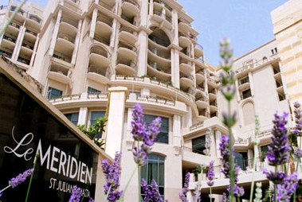

Monday 08th -Monday 15th December

8 night Package Single:€956/£717/1104(USD)

8 night Package Twin :€1212/£909/1400(USD)

Thursday 11th -Monday 15th December

4 night Package Single:€ 595/£446/916(USD)

4 night Package Twin :€766/£575/1180(USD)

- Admission to All the Matches.
- Thursday Opening Ceremony.
- Private Airport Transfers.
- Buffet Breakfast.
- Official souvenir program signed by one of the players.
- Staff on site to assist.
- This package is to be sold in Euros.
- The above conversions are subject to exchange fluctuations.

Book your package early to avoid disappointment.

**Special Offers on Flights @ 216 euros**

ON LINE BOOKINGS: www.alleventsmalta.com

For any bookings/enquiries please contact us on: office@alleventsmalta.com
4* Golden Tulip, Vivaldi Hotel

The Golden Tulip Vivaldi is elegantly decorated, with a classical style that ponders on the musical talents of the Venetian virtuoso Antonio Vivaldi combining the local flavours of the Mediterranean whilst ensuring International standards. It is located just 50 metres from the sea and 300 metres from the Dragonara Casino. When you stay at the Golden Tulip Vivaldi you are in the midst of MaltaÂ’s top entertainment spot, St. JulianÂ’s. Surrounded by shopping attractions, business opportunities and great restaurants.

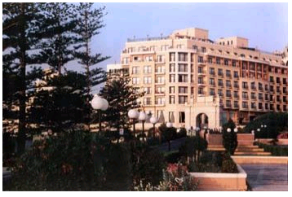

Monday 08th -Monday 15th December

8 night Package Single:€666/£499/769(USD)

8 night Package Twin :€846/£635/977(USD)

Thursday 11th -Monday 15th December

4 night Package Single:€ 419/£314/645(USD)

4 night Package Twin :€549/£412/845(USD)

- Admission to All the Matches.
- Thursday Opening Ceremony.
- Private Airport Transfers.
- Buffet Breakfast.
- Official souvenir program signed by one of the players.
- Staff on site to assist.
- This package is to be sold in Euros.
- The above conversions are subject to exchange fluctuations.

Book your package early to avoid disappointment.

**Special Offers on Flights @ 216 euros**
ON LINE BOOKINGS: www.alleventsmalta.com

For any bookings/enquiries please contact us on: office@alleventsmalta.com
3* Alexandra Palace Hotel
The Alexandra Hotel Malta is perfect for all generations. Ideally positioned in a most popular area, St. Julians. This hotel is in the midst of the best five star hotels in Malta - in contrast to these, being a three star hotel, the Alexandra Hotel can offer the service at a more reasonable price. This therefore means that our guests enjoy their stay in the most sought after area in Malta – St.Julians, at an affordable price. All members of your family are guaranteed the best holiday in Malta!

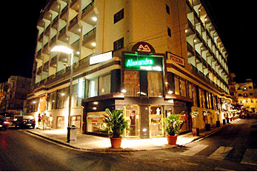

Monday 08th -Monday 15th December

8 night Package Single:€312/£234/361(USD)

8 night Package Twin :€400/£300/462(USD)

Thursday 11th -Monday 15th December

4 night Package Single:€ 217/£163/334(USD)

4 night Package Twin :€294/£220/452(USD)

- Admission to All the Matches.
- Thursday Opening Ceremony.
- Private Airport Transfers.
- Buffet Breakfast.
- Official souvenir program signed by one of the players.
- Staff on site to assist.
- This package is to be sold in Euros.
- The above conversions are subject to exchange fluctuations.

Book your package early to avoid disappointment.

**Special Offers on Flights @ 216 euros**
ON LINE BOOKINGS: www.alleventsmalta.com

For any bookings/enquiries please contact us on: office@alleventsmalta.com
3* Valentina Hotel

The Hotel Valentina is in the heart of the entertainment hub, and just minutes away from the national casino, public beaches, night clubs and restaurants, yet we are situated in a quiet residential area. So for a pleasant holiday book at the Hotel Valentina and we will ensure a holiday catered to all your needs.Internet access is available throughout the hotel.
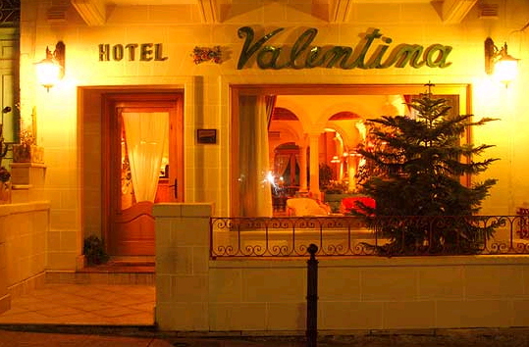

Monday 08th -Monday 15th December

8 night Package Single:€436/£327/504(USD)

8 night Package Twin :€549/£412/63(USD)

Thursday 11th -Monday 15th December

4 night Package Single:€ 288/£216/443(USD)

4 night Package Twin :€379/£284/583(USD)

- Admission to All the Matches.
- Thursday Opening Ceremony.
- Private Airport Transfers.
- Buffet Breakfast.
- Official souvenir program signed by one of the players.
- Staff on site to assist.
- This package is to be sold in Euros.
- The above conversions are subject to exchange fluctuations.

Book your package early to avoid disappointment.

**Special Offers on Flights @ 216 euros**

ON LINE BOOKINGS: www.alleventsmalta.com

For any bookings/enquiries please contact us on: office@alleventsmalta.com

