Chinese Billiards & Snooker Association
World Pool-bliiard association
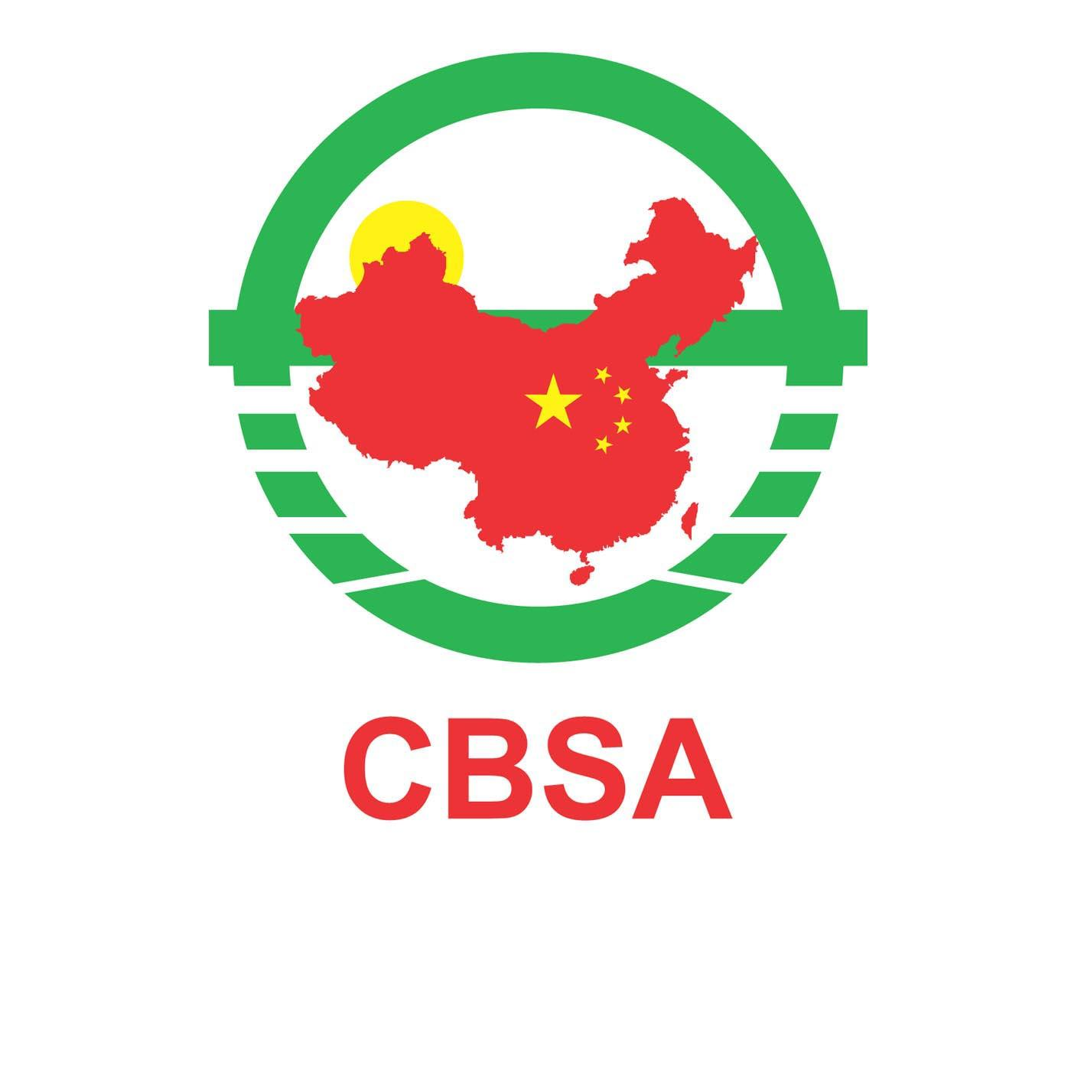
2011WPA Women’s 9-Ball World Championship
ShenYang - China
19rd – 25th September 2011

ENTRY FORM

NATIONAL ASSOCIATION:

FAMILY NAME:

FIRST NAME:

DATE OF BIRTH:

PLAYING HISTORY:

PERSONAL SPONSORS’ NAME AND VARIETY: 1.
(Very Important!)
2.

3.

PASSPORT NO.: DATE OF EXPIRY:

EMAIL ADDRESS:

FAX/TELEPHONE NUMBER:

THIS FORM PLUS A PASSPORT SIZE PHOTOGRAPH OF PLAYER
MUST BE RETURNED BY EMAIL BEFORE 8th SEPTEMBER 2011
To the Secretary of Organize Committee of Shenyang.
Email Address: sygcc@sina.com

