ARE YOU THE NEXT EUROPEAN POOL CHAMPION
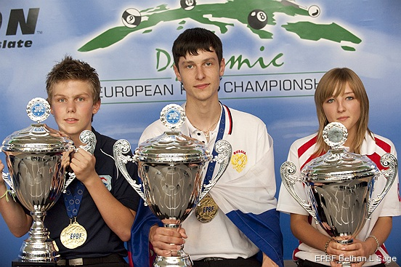
Qualification to the European pool championships are here on 13th June 2010

Mickey Flynn's American Pool
103 Mill Road
Cambridge CB1 2AZ
Tel; 01223 309000
Starting at 11.00 am Players must be present by 10.30 am

Categories; Pupils; Born during 1994 or after.
Juniors; Born in the years 1993/1992.
Girls; Born during 1992 or after.
Players must hold a valid British passport.

Registration; At the club before 13th June, first 16 registered in each category will participate in this qualifier. Free Entry. Format; 9-ball. No club membership required.
For more information contact the club or the GBPA youth Director Ian Walker, mobile 07846147146 Email; snafuboy@sky.com

