The main topic of the 7th China Guangzhou International Leisure &Amusement Expo
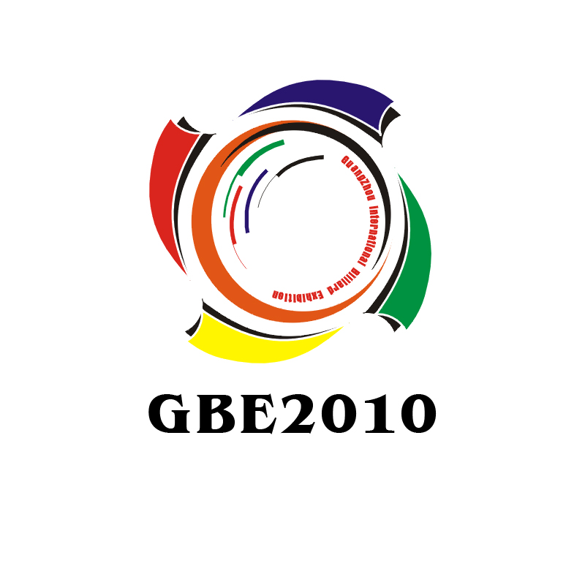
4th China (Guangzhou) International Billiards Exhibition (GBE 2010)
引领休闲时代 缔造娱乐商机
Date: March 30- April 1, 2010 Venue: China Import and Export Fair Pazhou Complex

More than 200 exhibitors, 500 booths, 15000 square meters, 13000 visitors!

VISITOR INVITATION
GBE has been successfully held three times. As good effect for last three years, it's thought highly by the exhibitors and visitors and got the reputation as the most famous billiard exhibition in Asia.
Therefore, GBE is taken for granted to become the best business platform for billiard, snooker,pool suppliers and buyers to find business partners and meet new or old friends.
GBE2010 will be held in China Import and Export Fair Pazhou Complex from March 30- April 1, 2010. Now 400 booths have been booked(the deadline is on Jan.20th,2010). The booths were 167 in GBE2009．The goal of GBE2010 is 500 booths. All the members of GBE2010 Organizing Committee will do our best to make it come true.
So you will meet a lot of new suppliers on GBE2010. The new suppliers has booked booth such as OLD WORLD,Sunrat,KANGHOM, Meijia, Chamberlain Billiards，Guanjin, Mingtai, Born Winner, Niushan, ect.The GBE2009 suppliers will see you again of course. Thanks for their support GBE all the time, including Brunswick, Xingpai,Yalin,Master cue, Wiraka, Fury(Kao Kao),K.F Cue, JYU BEN,Chaojie, Biaoli, J. G. P., Meilin,Centric,Waters Enterprises, ect.
Welcome all the billiards professionals to attend or visit GBE2010. Let’s celebrate the billiards industry feast together!
Contact us
Name: Eva Deng (Ms)
E-mail: e.gra@gzhw.com,dywaiwen@yahoo.com.cn
Website: www.gbechina.com

The main topic of the 7th China Guangzhou International Leisure &Amusement Expo
4th China (Guangzhou) International Billiards Exhibition (GBE 2010)
引领休闲时代 缔造娱乐商机
Date: March 30- April 1, 2010 Venue: China Import and Export Fair Pazhou Complex
VIP VISITOR APPLICATION FORM
Fax: +86 20 8257 9220 Web: www.gbechina.com

Date: March 30- April 1, 2010 Venue: China Import and Export Fair Pazhou Complex
Notice: Begin to unbuild booths at 2:30pm of 1st. Please visit before the time.
Company Name
Address |  |  |  |  |  | Zip Code
Tel |  | Fax |  |  | Web
Contact person |  | Title |  |  | Email
The number of persons will come
The products you interested in
□Billiards/Pool/Snooker Tables □Billiards Slate
□Billiards/Pool/Snooker Cloth □Cue Cases
□Billiards/Pool/Snooker Pockets □Billiards Balls
□Cues □Chalk
□Lighting □Tripod
□Special Gloves □Accessories
Others leisure products, such as KTV, Games, Spa products,sport products and so on.
Others
Nature of your company
□Billiards Club □Billiards Distributor
□Billiards Agent □Importer/Exporter
□Sport Products Retailers □Amusement Center
□Leisure Sites □Billiards manufacture
□Individual □Lovers
Others

Contact us
Address: Guangzhou Grandeur Exhibition Co., ltd
Room 802B, Jiayue Building, Zhongshan Mid Avenue, Guangzhou, China
Name: Eva Deng (Ms)
Mobile:+86 134 8029 4087
Phone: +86-20-88196839 Fax: +86-20- 8257 9220
E-mail: e.gra@gzhw.com,dywaiwen@yahoo.com.cn Website: www.gbechina.com

