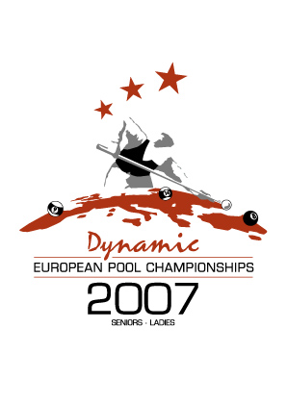
EPBF Seniors & Ladies
European Championships 2007

Venue Golden Tulip Jagershorst
Valkenswaardseweg 44
5595 XB Leende
Netherlands

Schedule 31.08.07 Arrival day - till 18.00 h accreditation
18.30 h teamleader meeting
01.09.07 Start of matches
09.09.07 Day of departure

Hotel Golden Tulip Jagershorst
Valkenswaardseweg 44
5595 XB Leende
Netherlands

And if necessary ( Shuttle service to Jagershorst will be provided)

Golden Tulip Weert
Driesveldlaan 99
6001 KC Weert
Netherlands

Single room € 85,00
Double room € 105,00
Triple Room € 135,00

The rooms must be paid upon arrival, it is possible to pay by credit card. All room rates are inclusive breakfast and excl. City Tax.

Booking Up to 10.08.2006 an / to

Gre Leenders
E-Mail. Gre.leenders@planet.nl

Airport Amsterdam – Brussels – Dusseldorf
Cheap Airlines – Eindhoven - Maastricht

Transfer It is possible to arrange a transport from Airport to Venue / Hotel.
Please ask for the prices when you know what airport is valid.

EPBF Seniors & Ladies European Championships 2007

Age group Born before 01.01.1968

Participants Seniors : max. 96
Ladies : max. 48

Disciplines Seniors – 8 Ball, 9 Ball, 14.1, Team
Ladies – 8 Ball, 9 Ball,

Races 8 Ball 9 Ball 14.1
Seniors 7 9 100
Ladies 5 6

Entry fee 8 Ball, 9 Ball, 14.1, Team:
Ladies 110,00 € each player / each discipline
Seniors 110,00 € each player / each discipline and team

Tournament Director Anamaria Matesic

Tournament Leader Thomas Overbeck

Wish list Up to : 29.6.2007 to

EPBF
Gre Leenders

Clercstr. 2
NL – 6441 CT Brunssum
Tel. +31 45 527 58 54
Fax +31 45 564 06 10
Email gre.leenders@planet.nl

If the mentioned deadline will be not regard, then there is no right for participating at the European Championships.

